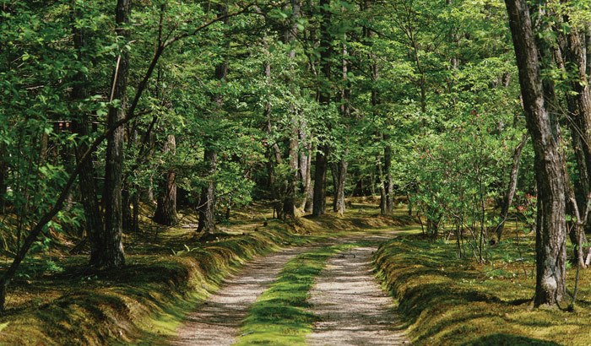  Sunday 5.8  14:00-17:30  Nature Walk  There is treasure all around us…one just has to have open eyes to see it  Come and enjoy an informative walk in the local forest. I will be pointing out medicinal plants that grow all around us. We will gather plant material and make tinctures. You will learn how easy it is to take your health back into your own hands. | Nature Weekend!  ────  How to make tinctures  ────  Only 10 spots available so RSVP soon!  ────  Enjoy great company, refreshments and leave with the remedies that you have created  ────  Cost: 200 kc per person  Krista’s Herbarium  U 1165 Hluboka nad Vltavou  739 877 924  kristasherbarium.com  kristasherbarium@gmail.com

