Recipes | May 20, 2018  Spa Workshop
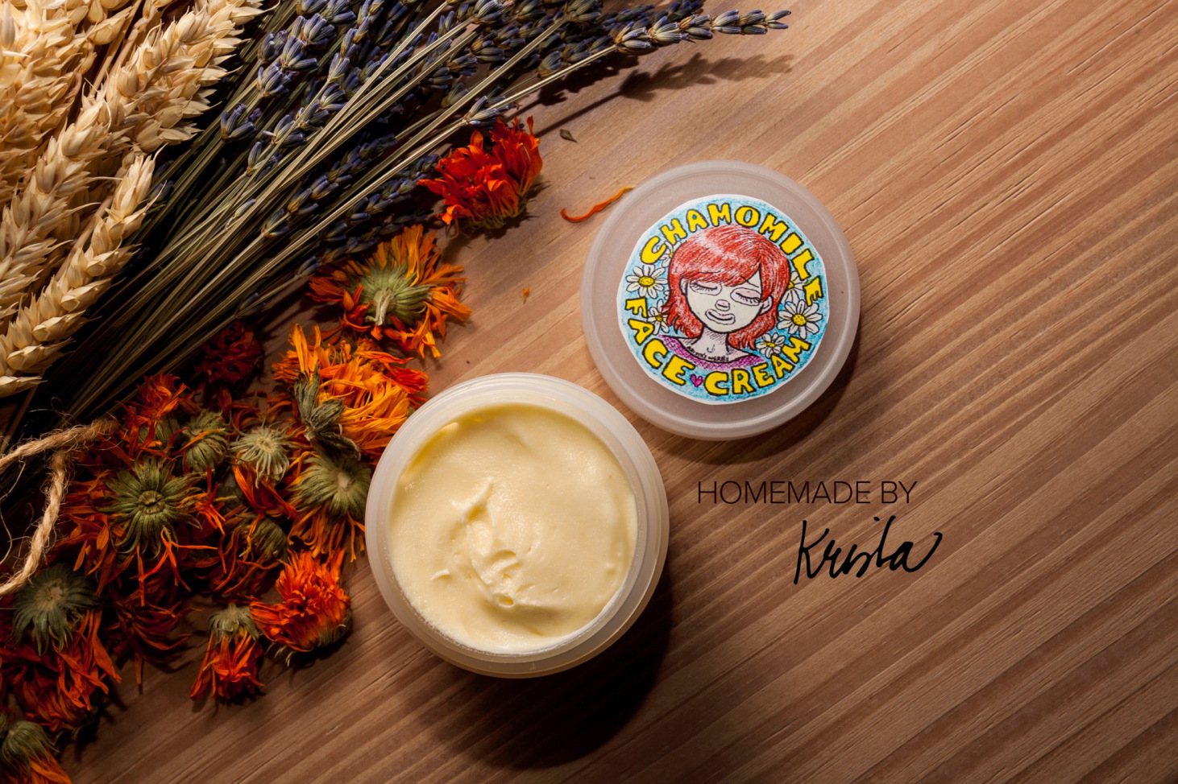  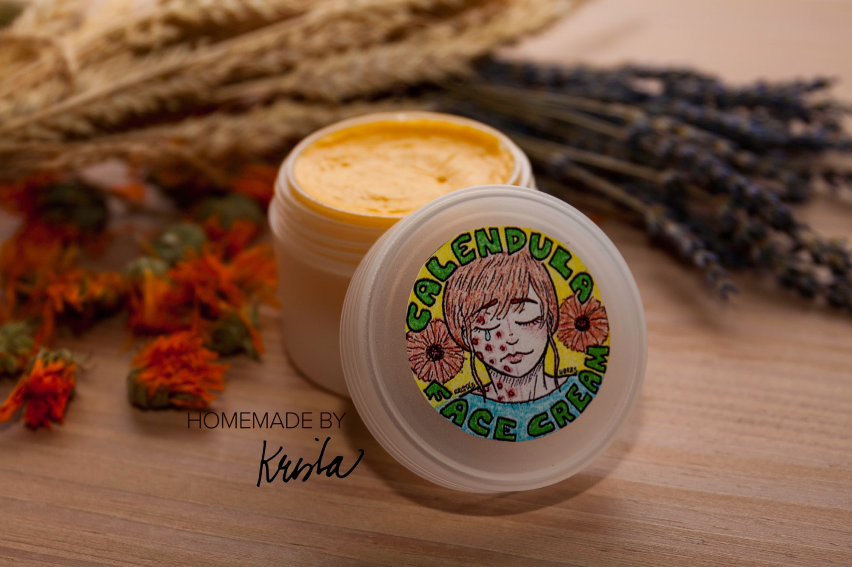 | Chamomile Face Cream/ Calendula Face Cream  - 3/4 cup (180ml) Chamomile or Calendula-infused sweet almond oil  - 1/4 cup(60ml) Balm of Gilead -infused almond oil  - 1/8 cup (30 ml) Shea butter  - 1/8 cup (30 ml) Coconut oil  - 1/8 cup (30 g) beeswax  - 1/4 cup (60ml) commercially prepared organic aloe vera gel  - 3/4 cup (180 ml) rose, lavender or orange blossom hydrosol  - 10 drops of Vitamin E oil  - A few drops of lavender essential oil  Combine the oils, butter and beeswax in a saucepan over very low heat until everything is melted together  Pour into a measuring cup or container and let cool until the mixture is somewhat firm, thick and creamy  Scrape the oil mixture into a blender.  In a separate bowl. Combine the hydrosol, gel and essential oil  Turn the blender in full speed and slowly drizzle the the water mixture into the vortex created by the blender  Continue blending until all the water mixture has been absorbed by the oil.  The blender should "choke" as the mixture thickens and becomes creamy  After turning off the blender, scoop the cream into small jars.  Store the cream in a cool dark place.
Medicinal Actions:
Calendula: Vulnerary, anti-inflammatory, antibacterial, immune stimulant, antifungal, antiviral, cholagogue, diaphoretic, lymphatic, antispasmodic, emmanagogue

Chamomile: soothing, vulnerary, affinity for skin disorders such as eczema and psoriasis, anti-inflammatory

Shea butter: moisturising, anti-inflammatory, aids in skin's natural collagen production

Balm of Gilead: antioxidant, heals scars, clears up eczema and psoriasis, anti-inflammatory

Aloe Vera: vulnerary, soothing, antioxidant, antiviralz anti-inflammatory

Lavender: antibacterial, soothing, anti-inflammatory, nervine

